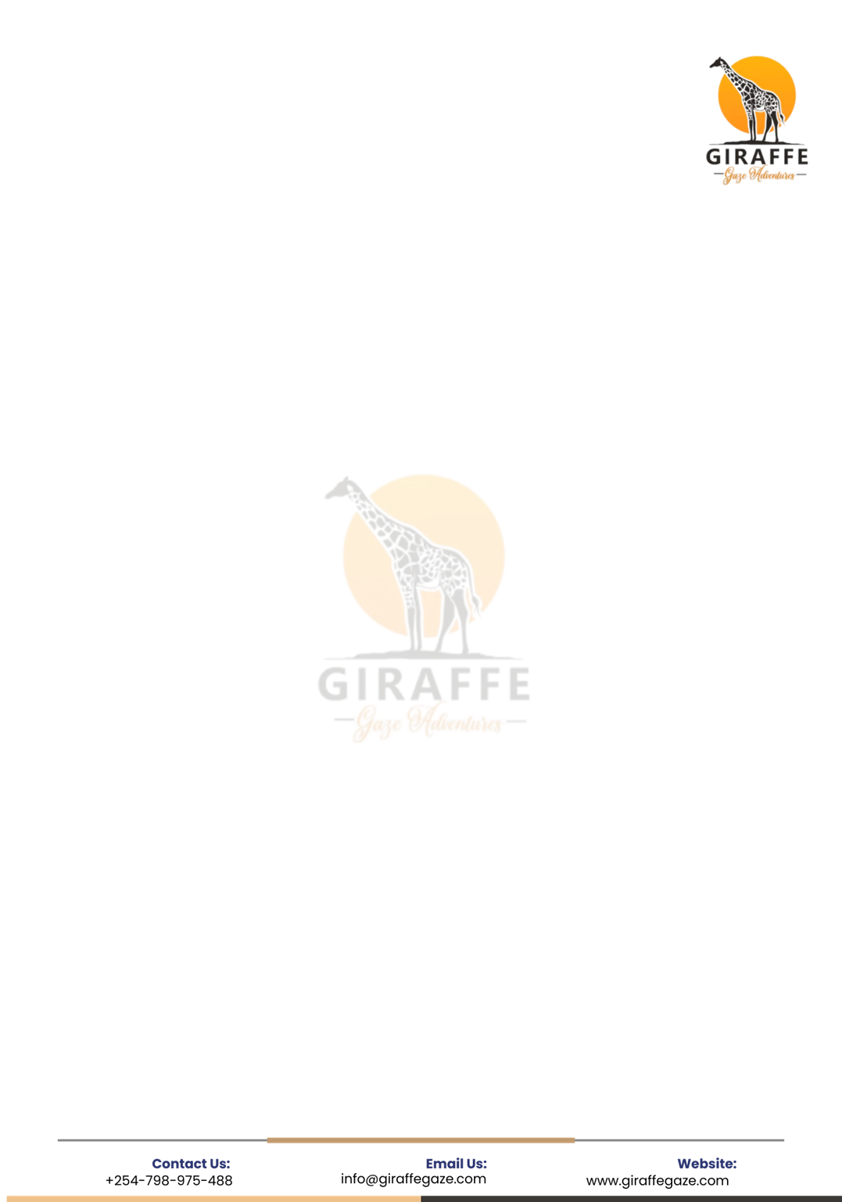

Terms & Conditions

Terms & Conditions

Disclaimer
These Terms & Conditions replace all previously issued conditions and take effect immediately.

1. Booking & Reservation
- All prices are quoted in USD ($) unless otherwise agreed in writing.
- A 40% deposit is required to confirm your booking. This covers accommodation and any pre-booked activities or permits.
- The balance is payable 14 days before the safari start date to allow smooth planning and logistics.
- Your safari consultant can arrange a milestone or flexible payment plan upon request.

2. Payment Policy
- We accept online card payments through a secure, PCI DSS–compliant payment gateway.
- Currently, we absorb card transaction charges; however, this policy may change in the future.
- SWIFT bank transfers are also accepted. Official bank details will be shared upon request via our designated email.
- We are not responsible for payments made outside our official payment channels.

3. Accommodation
- Rates are based on double/twin rooms shared by two guests.
- Single rooms can be arranged at an additional single supplement cost.
- If the first-choice property is unavailable, we reserve the right to book a comparable alternative of similar standard.
Definitions:
- Per Person Sharing: Cost is split equally between two guests sharing a room.
.

- Single Supplement: An extra charge applies for guests staying alone in a room.

4. Meals & Dietary Requirements
- Unless stated otherwise, all safaris are booked on Full Board (breakfast, lunch and dinner).
- On arrival and departure days, meals may be limited to one or two, depending on flight times and itinerary.
- Special dietary needs (vegetarian, vegan, halal, allergies, etc.) must be communicated at booking confirmation.

5. Transportation
- Safari game drives are conducted in 4x4 safari vehicles.
- City and airport transfers may use minivans or sedans.
- The company may engage licensed subcontractors when necessary.
- Bottled water is provided during safaris. We recommend using bottled or purified water at lodges and hotels.
- Many parks are eco-friendly and discourage plastic bottles; guests are encouraged to carry a reusable water bottle.

6. Tour Language
- All safaris are conducted in English by default.
- Guides speaking French, German, Italian or Spanish can be arranged upon prior request at an extra cost.
- Last-minute requests for bilingual guides or translators may not be possible.
7. Park, Reserve & Conservancy Rules
Guests must observe all rules and regulations within national parks, reserves, conservancies and sanctuaries. Failure to comply may result in fines, penalties or injury, for which the guest will be fully responsible.
Prohibited actions include (but are not limited to):
- Standing or hanging out of the safari vehicle

- Feeding wild animals
- Littering
- Making loud noises or playing music
- Flying unauthorized drones
8. Changes to Itineraries & Pricing
- We make every effort to operate tours as planned; however, we reserve the right to adjust itineraries, accommodation or sequence due to weather, safety or operational reasons.
- Tour prices are based on current tariffs and may change without prior notice.
- Any increases beyond our control (e.g. park fees, government taxes, activity charges) will be communicated promptly.
9. Travel Regulations, Visas & Health
- Most travelers require an e-Travel Authorization for Kenya and visas for other African destinations.
- Visa and travel documents are generally processed online. Your consultant will guide you after booking confirmation.
Health & Vaccinations:
- Consult a travel clinic or doctor well in advance of travel.
- Malaria prevention is recommended, including protective clothing after dark.
- Yellow Fever vaccination is advised when traveling to or through endemic regions.
- Travelers should comply with all health advisories issued by authorities.

10. Travel Insurance
- We strongly recommend purchasing comprehensive travel insurance covering cancellations, medical emergencies, evacuation and lost luggage.
- Please confirm whether your personal health or life insurance provides coverage during safari travel.
- We do not sell travel insurance. Insurance must be purchased in your home country.

Local Emergency Medical Evacuation:
- Emergency land, sea or air evacuation can be arranged locally prior to travel date at USD 40 per person.
- This service is not a medical cover or travel insurance policy and does not replace travel insurance.
11. Local & Regional Air Transfers
- All scheduled and charter flights are operated by licensed and regulated local aviation companies.
- Strict baggage weight limits apply. Excess baggage may require pre-paid upgrades.
- Connecting flights may experience delays, usually communicated in advance.
- Some regional flights may land at alternative airports for immigration processing (e.g. Masai Mara–Entebbe flights via Kisumu).
12. Cancellation Policy
All cancellations must be made in writing.
Park, Conservancy & Sanctuary Fees:
- Park entry tickets are non-refundable once issued.
- Rescheduling may be allowed at the discretion of the relevant authority if prior written notice is given.
Gorilla & Chimpanzee Trekking Permits:
- Permits are confirmed only upon full payment.
- Permits are non-refundable.
- Uganda Wildlife Authority allows up to two complimentary reschedules.
- A third reschedule requires special approval and attracts a 25% permit penalty.
Hotel Cancellation Charges:
- 90–30 days before travel: 25% penalty

- 30–15 days before travel: 50% penalty
- 15–7 days before travel: 75% penalty
- Within 7 days: 100% penalty

13. Child Policy
Child rates vary by property and activity. General guidelines:
- Infant (0–3 years): Free of charge
- Child (4–11 years): Pays a reduced percentage of the adult rate
- Adult (12+ years): Full adult rate applies
- Child Sharing: Discount applies when sharing a room with an adult
14. Complaints & Feedback
- Any issues during the safari should be reported immediately to your tour consultant for quick resolution.
- If unresolved, a detailed written complaint must be submitted via email within 14 days after the tour ends.
- Complaints received outside this period may not be considered.

15. Force Majeure
We are not liable for delays, changes, cancellations or losses caused by events beyond our control, including but not limited to natural disasters, war, terrorism, civil unrest, strikes or government actions.

16. Liability
- Giraffe Gaze Adventures Limited and its agents are not responsible for personal injury, illness, death, loss, theft, damage, delays or itinerary changes caused by force majeure or third parties.
- We are not liable for airline delays, cancellations or denied boarding.
- Our liability is governed exclusively by the laws of Kenya and any claims shall be subject to the Kenyan judicial system only.

Giraffe Gaze Adventures Limited

