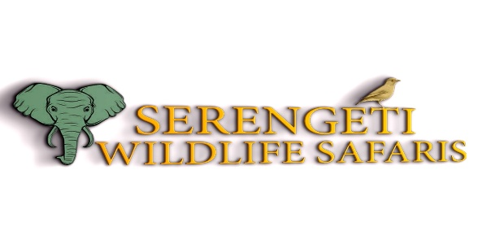
*TERMS AND CONDITIONS*
Clients entrust Serengeti Wildlife Safaris with their safari experience, receiving comprehensive itineraries encompassing destinations, lodging, and transportation. While the company endeavors to honor negotiated terms, unexpected occurrences like road closures, adverse weather conditions, or security issues may necessitate itinerary modifications, ensuring the safety and satisfaction of clients. Timely communication and alternative arrangements characterize our commitment to maintaining itinerary quality.

*PAYMENT TERMS*

Upon booking confirmation, clients receive detailed invoices outlining payment obligations:
- Camping safari bookings require a 10% deposit.
- Lodge safari bookings necessitate a 30% deposit.
- Tailor-made options may request a deposit ranging from 10% to 35%.
- Final payments can be made upon arrival, with online, bank, or cash payments preferred.

*METHODS OF PAYMENT*

Flexibility defines our payment methods, accepting bank wire/transfer, credit cards, and online platforms such as Pesapal. Clear instructions and banking details facilitate seamless transactions. For group bookings, separate payments from individuals are accommodated and managed through provided links, with the group leader assuming financial responsibility.

Quotations are provided in USD, Euros, pounds, and Tanzanian shillings. Cash payments are accepted in USD, Euros, and pounds, with bank transfers available for all currencies, ensuring convenience for our diverse clientele.

*INSURANCE*

Clients are urged to secure comprehensive travel and medical insurance covering personal injury, medical expenses, repatriation, and loss or theft of personal belongings. This precaution ensures peace of mind throughout their safari experience.

*CANCELLATION POLICY*

In the event of a cancellation, Serengeti Wildlife Safaris offers a refund up to one day before the scheduled trip, underscoring our commitment to client satisfaction and flexibility amidst unforeseen circumstances.

